Lab 1
Student Name |  | CSUSM Email | Contribution Percentage
1 | Noah Boyd | Boyd074@csusm.edu | 50%
2 | Andrew Mueller |  | 50%

Instructions:
- Paste your UML class diagram, make sure it is still readable in the report;
- Paste a screenshot of a run of your program.
- Paste your code implementation.
Problem 1:
The ABC Company typically uses an object of the SortingUtility class to sort products. A product has at least three attributes: ID, name and price. All are accessible through their corresponding get() method but the ID is fixed once set.
The SortingUtility class implements two private sorting algorithms, bubbleSort and quickSort, each of which takes the list of products and returns an ordered list of products. The SortingUtility class also has a public method List<Product> sort(List<Product> items, int sortingApproach), which simply calls the specified sorting approach (i.e., bubbleSort or quickSort) to return a list of sorted products to its client.
The SortingUtility currently does not log the list of sorted products before returning it to the client. Now the ABC Company would like to have an improved sorting service that can log (for this lab, simply printing to the display console) the list of sorted products before returning it to the client. To implement this improved service you cannot change the existing SortingUtility class for compatible reason (except that you may need to relate it to a super class or an interface) . Moreover, the returned products from bubbleSort should be logged (printed) with ID followed by name and price, whereas the returned products from the quicksort should be logged (printed) with name first followed by ID and price.
- What design pattern can be used? Document your pattern-based design in UML class diagram, ensure attributes, methods, visibility, arguments and relationships are correctly included.
- Implement your pattern-based design in Java. Implement two test scenarios: one using quicksort to sort a list of products such as books, bags, and buttons, another using bubblesort to sort the same list of products.
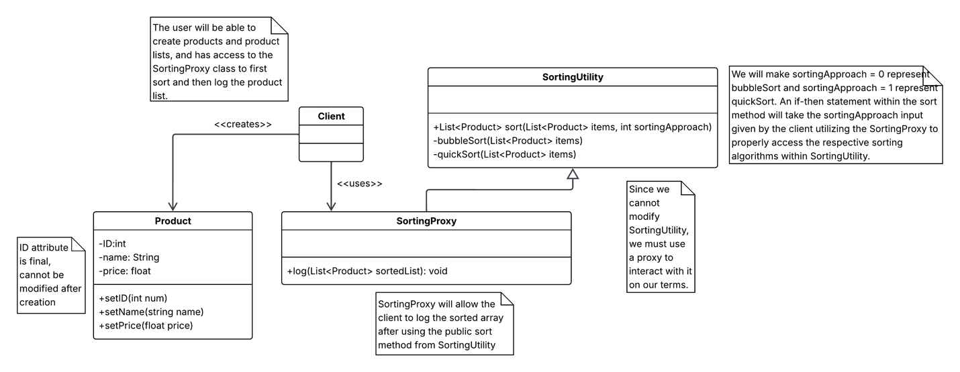
import java.util.ArrayList;
import java.util.List;

class Product {
// Initializing variables
public static int global_ID = 0;

int ID;
String name;
double price;

// Constructor
public Product(String name, double price){
this.setName(name);
this.setPrice(price);
this.ID = global_ID + 1;
global_ID++;
}

// SETTERS !!! There is no set ID because id is final and is automated when created,

void setName(String newName){
this.name = newName;
}

void setPrice(double newPrice){
this.price = newPrice;
}

// GETTERS !!!
int getID(){
return this.ID;
}

String getName(){
return this.name;
}

double getPrice(){
return this.price;

}

}

class SortingProxy extends SortingUtility {
public void log(ArrayList<Product> unsortedListOfProducts, int sortingApproach){
SortingUtility mySortingUtility = new SortingUtility();
if (sortingApproach == 0){ //BubbleSort format: ID, name, price
mySortingUtility.sort(unsortedListOfProducts, sortingApproach);
System.out.printf("%-5s%-13s%-5s\n%s\n", "ID", "Name", "Price", "-------------------------");
for (int i = 0; i < unsortedListOfProducts.size(); i++) {
System.out.printf("%-5d%-13s%-5.2f\n", unsortedListOfProducts.get(i).ID, unsortedListOfProducts.get(i).name, unsortedListOfProducts.get(i).price);
}
}
else if (sortingApproach == 1){ //BubbleSort format: name, ID, price
mySortingUtility.sort(unsortedListOfProducts, sortingApproach);
System.out.printf("%-13s%-5s%-5s\n%s\n", "Name", "ID", "Price", "-------------------------");
for (int i = 0; i < unsortedListOfProducts.size(); i++) {
System.out.printf("%-13s%-5d%-5.2f\n", unsortedListOfProducts.get(i).name, unsortedListOfProducts.get(i).ID, unsortedListOfProducts.get(i).price);
}
}
else{
System.out.println("\nSortingUtility sort method error: sortingApproach number unrecognized.\n");
}
}
}

class SortingUtility {
public ArrayList<Product> sort(ArrayList<Product> unsortedList, int sortingApproach){
if (sortingApproach == 0){
this.bubbleSort(unsortedList);
System.out.println("\nArrayList has been sorted with BubbleSort algorithm.");
}
else if (sortingApproach == 1){
this.quickSort(unsortedList, 0, unsortedList.size()-1);
System.out.println("\nArrayList has been sorted with QuickSort algorithm.");
}
else{
System.out.println("\nSortingUtility sort method error: sortingApproach number unrecognized.\n");
return unsortedList;
}
return unsortedList;
}
// BubbleSort
private void bubbleSort(List<Product> list) {
int n = list.size();

for (int i = 0; i < n - 1; i++)
for (int j = 0; j < n - 1 - i; j++)
if (list.get(j).getPrice() > list.get(j + 1).getPrice()) {
Product temp = list.get(j);
list.set(j, list.get(j + 1));
list.set(j + 1, temp);
}
}

// QuickSort
private void quickSort(List<Product> list, int low, int high) {
if (low >= high) return;

double pivot = list.get(high).getPrice();
int i = low;

for (int j = low; j < high; j++) {
if (list.get(j).getPrice() <= pivot) {
Product temp = list.get(i);
list.set(i, list.get(j));
list.set(j, temp);
i++;
}
}

Product temp = list.get(i);
list.set(i, list.get(high));
list.set(high, temp);

quickSort(list, low, i - 1);
quickSort(list, i + 1, high);
}
}

public class Main
{
public static void main(String[] args) {
Product product1 = new Product("Book", 10.99);
Product product2 = new Product("Button", 0.99);
Product product3 = new Product("Bag", 22.99);
Product product4 = new Product("Car", 2500.00);
Product product5 = new Product("Fancy Ring", 150.00);
ArrayList<Product> myUnsortedListOfProducts = new ArrayList<Product>();
myUnsortedListOfProducts.add(product1);
myUnsortedListOfProducts.add(product2);
myUnsortedListOfProducts.add(product3);
myUnsortedListOfProducts.add(product4);
myUnsortedListOfProducts.add(product5);
System.out.println("Unsorted array of products:");
System.out.printf("%-13s%-5s%-5s\n%s\n", "Name", "ID", "Price", "-------------------------");
for (int i = 0; i < myUnsortedListOfProducts.size(); i++) {
System.out.printf("%-13s%-5d%-5.2f\n", myUnsortedListOfProducts.get(i).name, myUnsortedListOfProducts.get(i).ID, myUnsortedListOfProducts.get(i).price);
}
SortingProxy mySortingProxy = new SortingProxy();
mySortingProxy.log(myUnsortedListOfProducts, 0);
mySortingProxy.log(myUnsortedListOfProducts, 1);
mySortingProxy.log(myUnsortedListOfProducts, 2);
}
}

< Please Insert a Screenshot of the successful sample code run >
Problem 2:
A video game has three modes: beginner, intermediate and advanced. For each mode chosen by a player, the game GUI shows two control objects: a character selection panel and a weapon selection panel. Note that (a) under different modes the system displays different character selection panels and weapon selection panels, and (b) it is possible that new modes and/or new control objects may be added in the future.


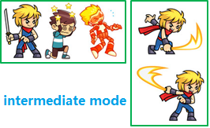
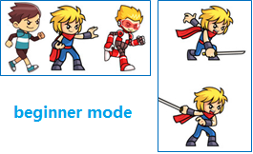

- Apply a design pattern to design the system such that the model can be easily extended to cover future changes without affecting the code on the client side. You should use a UML class diagram to document your design.
- Write Java code to implement your design. You should have a simple test class to show how it works.

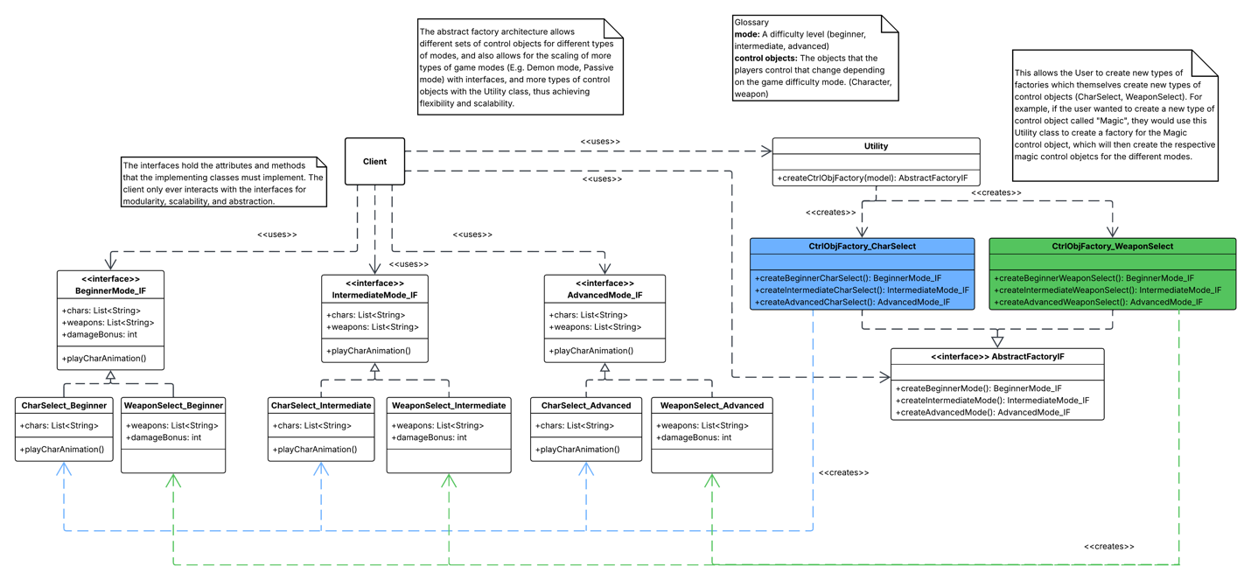

< Paste in completed Q2 code >

< Insert Screenshot of the successful Test Code Run

